**Using Geocoder**

*Before following this manual, check if all configurations were correctly made*

1. With Geocoder opened, click on *Options* on the top left corner. Copy the *Licenses* Keys (Application, Bing and Google) and save. Application will work if only one Map Key, but the Application Key is mandatory.

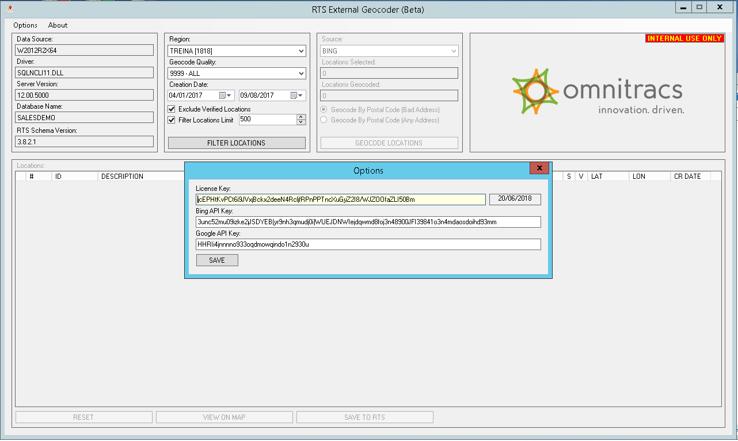

If you get a License Key expiration warning. Contact Omnitracs do Brasil Support team for a new Application License key.

1. Geocoder automatically loads the RTS regions. Choose on the filter box (second from the left), the region, Geocode Quality, dates, Exclude Verified Locations option, Location Limit filter and click the button *Filter Locations*. The number between brackets represents the number of clients on that region. The dates are predefined to show the first and last client registered, but you can change de values any time and re-run the filter pushing the button Filter Locations. This step only shows the data according to the selected filters.

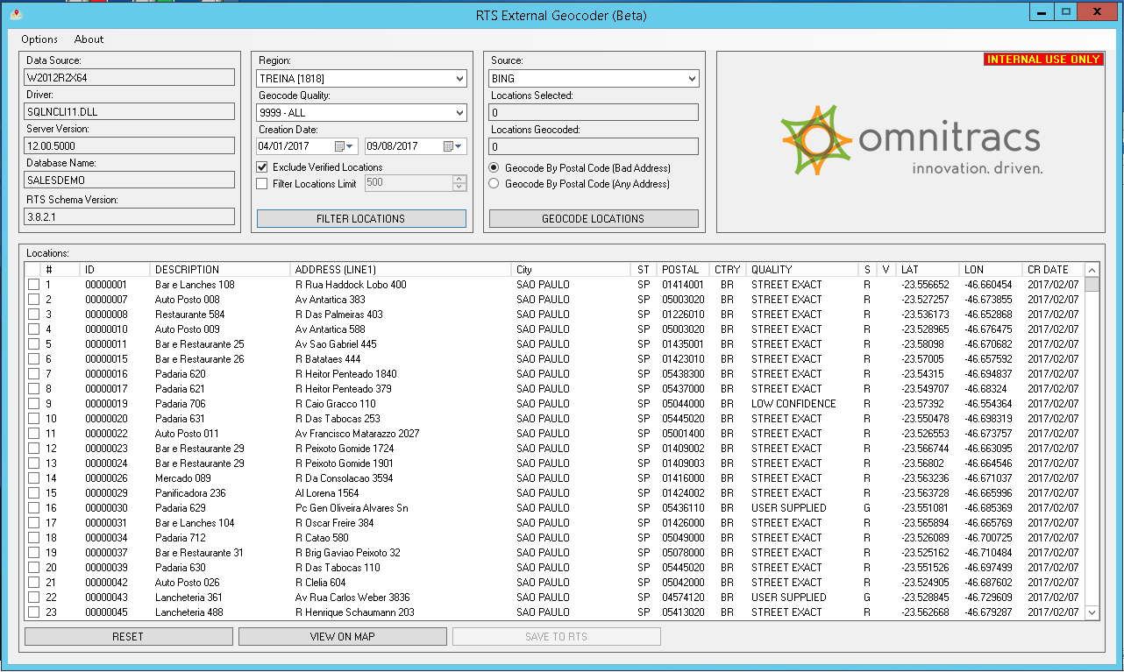

1. Select the locations that will be geocoded checking the box on the left as the next picture shows. The first column header inverts the selection of all locations, for example, if all boxes are blank, clicking on the header will check all boxes.

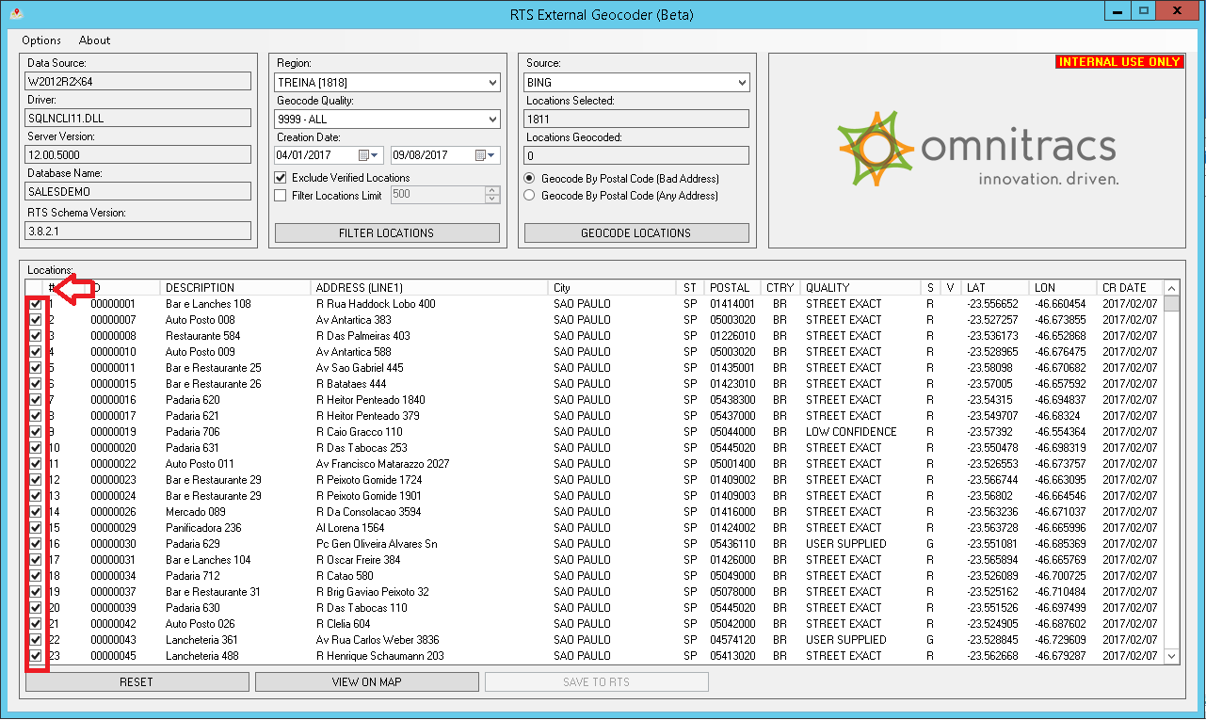

On the box *Source (third from the left)*, select Bing or Google and click the button *Geocode Locations to process the selected locations*. Verify if all parameters are correct and click Yes.

The first option above the button *Geocode Locations*, *Geocode By Postal Code (Bad Address)*, uses the address as basis and if it is incomplete, the ZIP code will be used to geocode. The second option *Geocode By Postal Code (Any Address)* uses only the ZIP code as basis.

The minimum parameters to use Bing as a source are: City, State, complete ZIP code and country. If any of this fields are blank, the quality will show as MISSING DATA.

Using Google as source, the minimum parameters are the ZIP code and country. If any of this fields are blank, the quality will show as MISSING DATA.

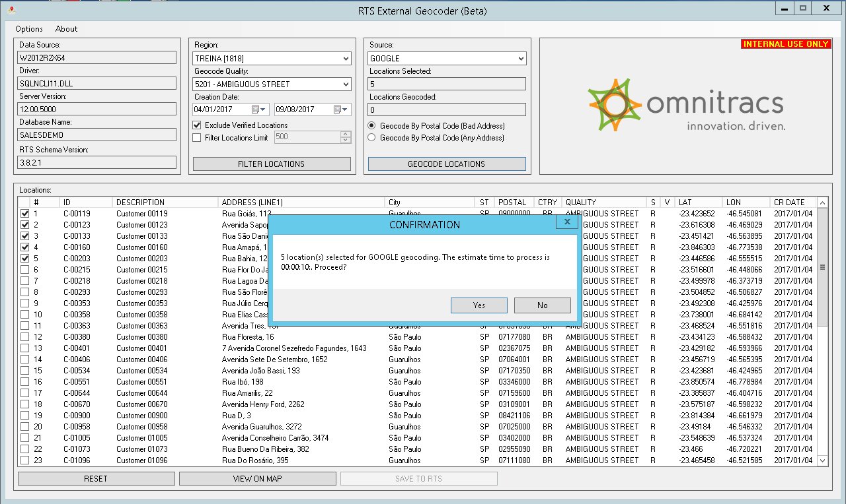

1. After geocoding, the quality will change according to the chosen source and the column “S” will be filled with the source initial. Using Bing it will fill with a B and using Google with a G. Locations that were geocoded or not geocoded in Roadnet will appear with a R. This does not mean that the locations cannot be geocoded with Geocoder.

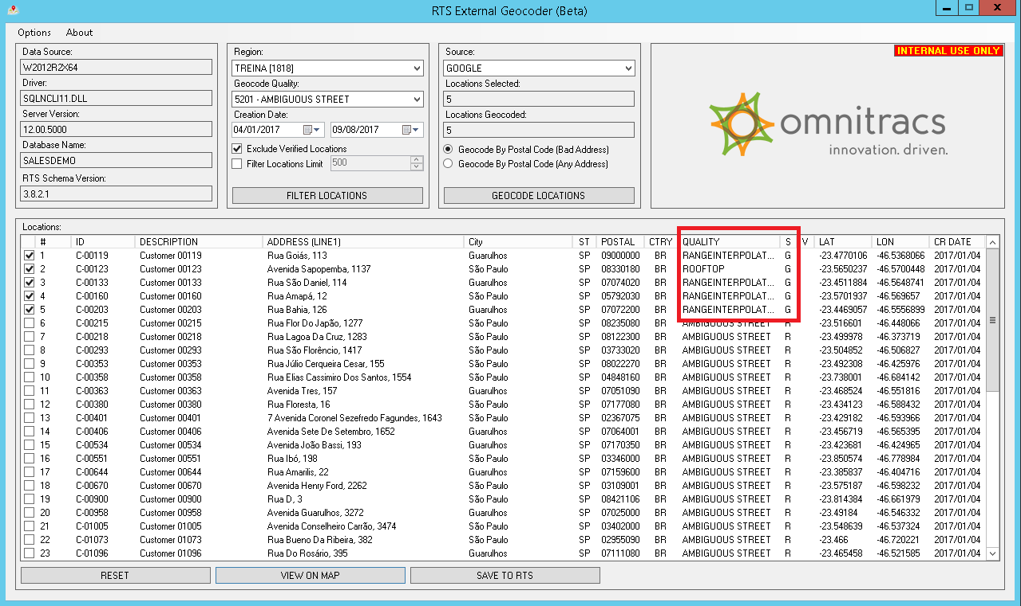

1. To see the location on the map, click the button *View On Map* and it will open a new window with the Map View. This can be done before or after geocoding and the parameters for the visualization are latitude and longitude. The source will be the same that it is selected on the box *Source*. On the *Map View form* there is the possibility to show the satellite view (*Sat View*) and change the zoom (*Low, Medium, High*).

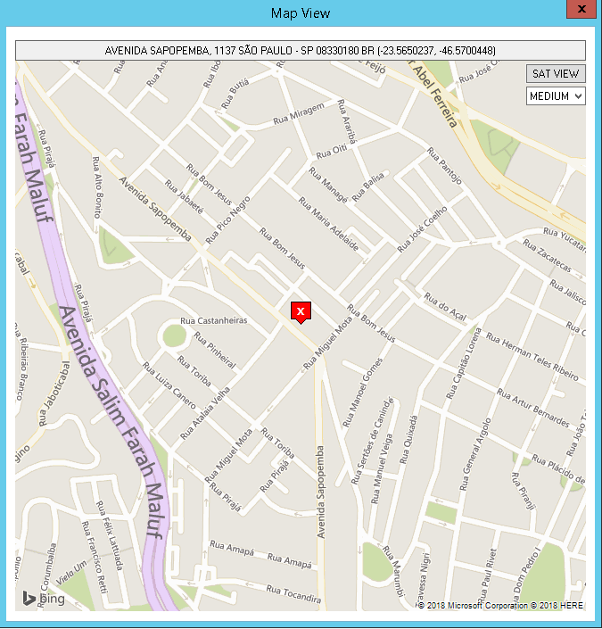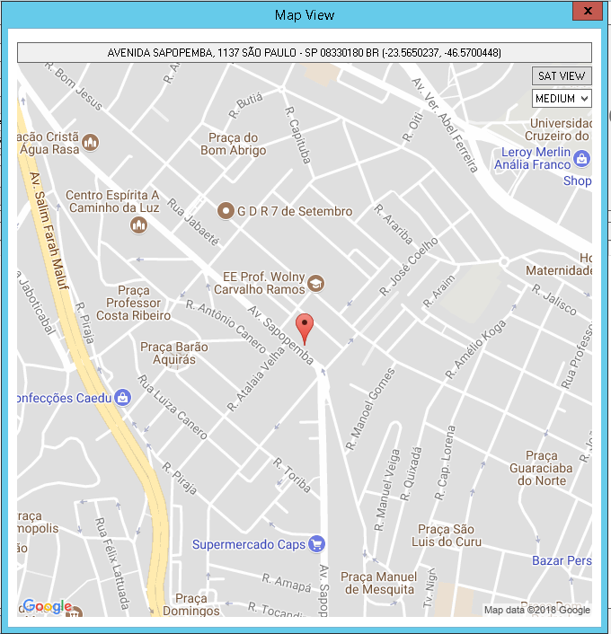

1. The button *Save to RTS* save the new data directly to Roadnet DB. It will only save the locations selected.
2. The button *Reset* on the bottom clears all the data on the screen as if the program was just opened. Any modification made and not saved will be lost by clicking on this button.
3. To verify the new data on Roadnet, the locations modified using Geocoder will have the field “Alternate Contact” filled with the same description of quality from the tool.

